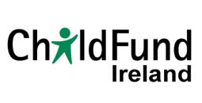
Strategic Plan 2014 – 2018
Summary

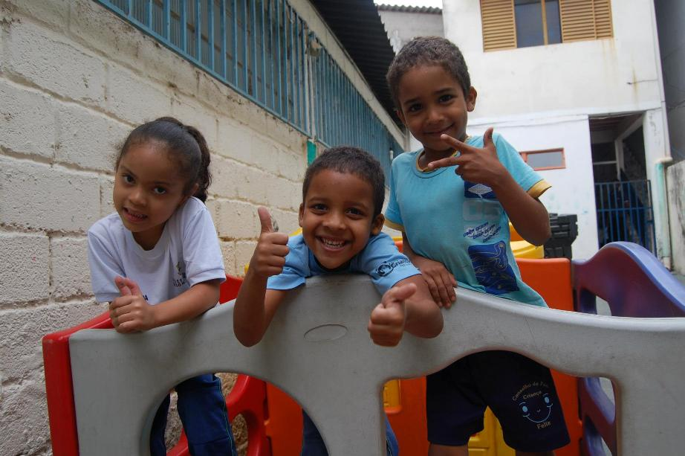
Children playing in Conselho de Pais Criança Feliz project in Belo Horizonte, Brazil

Executive Summary
ChildFund Ireland works on the basis of four to five year strategic planning cycles. This document sets out the methodology, contextual analysis, progress made in the previous strategic plan period and sets out ChildFund Ireland’s strategic focus, principles and approach. These formed the basis for planned and setting out of six objective goals, strategies to achieve the goals as well as indicators to measure accomplishment of the goals during the period 2014 to 2018.
ChildFund Ireland remains committed is to work internationally to develop an enabling environment where children’s basic needs are met and their rights are promoted and respected. Making progress during the previous strategic planning period of 2009 – 2013 was both positive and challenging. Through the skill of the staff and leadership of the board, ChildFund Ireland has maintained excellent support to child sponsors, participated in networks and Alliance initiatives and secured funding through Irish Aid for programmes to support child protection and development in several developing countries.

Despite the progress achieved throughout the period, the recession has brought challenges in terms of maintaining income levels; this impact is expected to continue for the next few years therefore achieving financial sustainability is one of the priority goals of the strategic plan for 2014-2018. ChildFund will continue to achieve the highest possible standards of transparency and accountability as well as maintain quality service to sponsors and donors. In order to demonstrate impact of programmes supporting children in developing countries strategies will be undertaken to ensure they are of the highest quality and achieve results; this will not only improve outcomes for the children and communities targeted by the programmes but will be used to attract funding from institutional donors. ChildFund Ireland will contribute to the Irish public’s understanding of international development including children’s rights issues; this along with other strategies will extend ChildFund Ireland’s profile as a champion of children’s rights and an organisation supporting quality programmes and child sponsorship opportunities.

Introduction and Strategic Planning Methodology
In the run up to the end of the previous strategic plan timeline (2009 - 2013), ChildFund Ireland’s board secured the services of an independent consultant to assist the organisation to develop a strategic plan for the next five year period of 2014 – 2018.
A review of the current vision, mission, principles, work focus and approach was undertaken to ensure that these are still in line with the aims of the organisation’s work in the next five years and consistent with the company’s registration objectives.

Strategic Plan 2009 – 2013 Progress
A comprehensive review of progress against the 2009 – 2013 strategic plan was undertaken in the first quarter of 2012 and a report produced. Subsequent progress was assessed based on the 2012 annual report as well as contributions from staff during the strategic planning session.
ChildFund Ireland made good progress on many of the strategies as set out under each goal however there were also some challenges. The two departments – Programmes and Grants and Finance and Sponsor Relations are small in terms of staff numbers yet manage a wide area of work: programmes, donors, sponsors, public relations, financial management, advertising, local networking and work with ChildFund Alliance. The areas of progress have been divided by the main areas of work:
- Organisational Income and Resources
- Sponsorship
- Programming
- Profile and Networking
- Governance and Accountability

Contextual Analysis
In setting the scene to develop a strategic plan it is important to assess the wider context of the environment in which ChildFund Ireland operates. To do this, the team undertook a PESTLE review assessing the current and future operating environment within Ireland, Europe and the world in the following areas: Political, Economic, Social, Technology, Legal and Environment. This was followed by an analysis of ChildFund Ireland’s strengths, weaknesses, opportunities and threats.

Organisational Income and Resources
The most important development in terms of external environment during the previous strategic plan period of 2009-2013 was the economic recession. The effects of the recession will continue to impact the organisation in the next number of years both in terms of sponsorship and grant income as it is predicted that it will take several years for the economy to swing back to a more positive position.
The tax rebate facility has been an important source of income for ChildFund Ireland. A new tax system will be applied to all donations made from 2013 onwards. It is expected that the new system will be “revenue neutral” but the exact impact of the change will only be known next year.
Sponsorship
Sponsorship levels have been steadily declining over the past number of years. The withdrawal of sponsors is very difficult decision for people to make especially as many of them have been sponsors for several years. This has also been difficult for ChildFund Ireland staff to manage as they deal with distressed people. This has brought about development of other options to continue supporting ChildFund Ireland such as project donations, emergency fund and others.

Another development over the past and one that will continue into the future is the move to electronic media for communication and payment. Cheques will soon be a thing of the past being replaced by use of debit cards and on line payment. Newsletters and other information from ChildFund Ireland is sent out by email and available on the website page.

Programming
ChildFund Ireland programmes currently focus on three ‘life stages’: healthy and secure infants; educated and confident children; and skilled and involved youth. Funding for activities at the first life stage is supported by Irish Aid until 2015. In 2013 the government of Ireland published its new policy on international development. The policy focuses on fighting global hunger, responding to the impact of climate change, supporting countries recovering from conflict, addressing gender inequality, fostering sustainable economic development, and undertaking a whole government approach to development (including exploring trade opportunities for Ireland).

Other contexts in international development include conflict over resource control and increasing disasters related to climate change. While ChildFund has not been involved in the area of emergency relief, this strategic plan provides an opportunity to consider if this is an area that the organisation will include as part of its mandate.

Profile and Networking
ChildFund Ireland has been involved with a number of networks to raise our profile as an actor within the field of child development. This has been a positive in terms of exposure within networks. It is however recognised that the time and commitment in this work has been substantial so best to assess the benefit of the commitments. It is also recognised that ChildFund Ireland is not well known in the public domain as a child sponsorship organisation in Ireland and perhaps more could be done to raise its profile in this domain.

Governance and accountability
Good governance and accountability will continue to be important aspects of organisational and programme management. The new Charities regulations means there is more to manage in terms of compliance. In some cases there is decreasing trust of charities – some occurring as a result of bad press; in other cases increasing competition between charities and the recession has resulted in donor fatigue. There has and will likely to be continued emphasis on producing results and demonstrating impact of programmes supported to ensure the long term funding made available is achieving sustainable improvements in the living standards of people in developing countries.

In addition to data protection legislation, more and more regulations, policies and procedures are being introduced by banks to limit criminal and terrorist activities.

Strengths, Weaknesses, Opportunities, Threats
The strengths of ChildFund Ireland were identified during a mid-term review of the 2009-2013 strategic plan. These include strong leadership, governance, and skill sets in a very supportive board; experienced and knowledgeable team; credible financial information available; transparency; new accessible website; limited bureaucracy and a quick decision-making processes; good working relationships with donors; recognised capacity within ChildFund Alliance and benefits as a member of the alliance; and high sponsor satisfaction levels. The current strategic plan will consider how these strengths can be maintained into the future as many are positive and can be used to address the weaknesses and threats identified.

Review and Refining ChildFund Ireland’s Vision and Mission Statements
ChildFund Ireland’s vision and mission statements from 2009 – 2013 were reviewed and resulted in minor changes. Following are the vision and mission statements for the 2014-2018 strategic plan:
ChildFund Ireland’s Vision is a world where children are happy and free to enjoy their childhood.
ChildFund Ireland’s Mission is to work internationally to develop an enabling environment where children’s basic needs are met and their rights are promoted and respected.

Proposed revision to the Strategic Principles, Focus & Approaches
In setting out the vision and mission, it was important to consider how the organisation is going to achieve the mission as set out. The mission is achieved through the objectives and outcomes but it is also important to be clear on the organisation’s principles, work focus and approach that form the basis from which to work. In reviewing these aspects contained in the 2009 – 2013 strategic plan, the following edits were suggested:
Principles
ChildFund Ireland is committed in everything we do:
- valuing all children equally regardless of gender, race or religious belief
- respecting the cultural diversity of the environment
- on-going learning in order to improve quality and increase effectiveness and
- achieving the highest standard of accountability, transparency and integrity.

Work Focus
ChildFund Ireland works
- with children, their families and their communities in developing countries
- with sponsors and individual donors
- with governments, institutions and corporate donors
- as an active member of ChildFund Alliance in the development of best practices to assure quality programmes for children
- in partnership with organisations who reflect our vision, mission and principles and
- to bring an awareness of the reality of children in developing countries to both the Irish public and the Irish Development environment.
Approach: ChildFund Ireland targets children who are living in extremely difficult circumstances as a result of poverty and/or conflict. The active participation of children is facilitated and their rights are promoted and protected through an integrated programme approach which builds on children’s resilience and reflects their specific life stage. Programme areas include health, sanitation, nutrition, early childhood development, education, and family income generation.
Concentration is placed on the holistic development of the child within his/her family and community, and communities are empowered to take responsibility for the development of their children. Attention is also paid to the protection of vulnerable children and children within emergency situations.
Working in Partnership: ChildFund Ireland works in partnership with other ChildFund Alliance members and with their implementing teams in developing countries to support the realisation of programmes for deprived, excluded and vulnerable children, their families and their communities.

Strategic Plan Goals, Strategies, Indicators and Monitoring

The goals for ChildFund Ireland’s strategic plan period 2014-2018 are:
Goal 1: Achieve financial sustainability to support child centred programmes
Goal 2: Continue to Achieve the Highest Possible Standards of Transparency and Accountability

Goal 3: Maintain Quality Service to Sponsorship Supporters

Goal 4: Maximise the Impact of ChildFund Ireland’s Programmes

Goal 5: Contribute to the Irish Public’s Understanding of International Development Including Children’s Rights Issues

Goal 6: Extend ChildFund Ireland’s Profile

Strategies to achieve these goals have been identified, responsibilities allocated and indicators of achievement have been set. Implementation of the plan will be monitored by staff and board throughout the five year period. A mid-term review is expected to occur at the same time as the completion of the post-2015 development agenda. The results of the review will help guide ChildFund through the remaining period of this strategic plan and together with the new sustainable development goals, provide direction for the subsequent strategic plan.

